CYCLE 4

PGMM1

AIM:
Write a program to print the Fibonacci series using recursion.
SOURCE CODE:

def fibano_recursive(a, b, num):

if num <= 0:
return

print(a, end=" ")

c = a + b
fibano_recursive(b, c, num - 1)

num = int(input("Enter number of terms: "))

if num <= 0:
print("Please enter a positive number")
else:
print("Fibonacci series:")
fibano_recursive(0, 1, num)

OUTPUT:

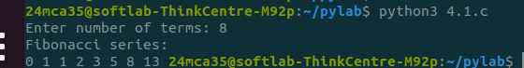

PGMM2

AIM:
Write the to implement a menu-driven calculator. Use separate functions for the different operations.
SOURCE CODE:

ef add(a, b):
return a + b

def sub(a, b):
return a - b

def mul(a, b):
return a * b

def div(a, b):
if b != 0:
return
else:
return "Error! Division by zero"

a = float(input("Enter number 1: "))
b = float(input("Enter number 2: "))

while True:
print("\nSelect operation:")
print("1. Addition")
print("2. Subtraction")
print("3. Multiplication")
print("4. Division")
print("5. Exit")

choice = input("Enter choice (1/2/3/4/5): ")

if choice == '1':
print(f"{a} + {b} = {add(a, b)}")
elif choice == '2':
print(f"{a} - {b} = {sub(a, b)}")
elif choice == '3':
print(f"{a} * {b} = {mul(a, b)}")
elif choice == '4':
result = div(a, b)
print(f"{a} / {b} = {result}")
elif choice == '5':
print("Exiting program.")
break
else:
print("Invalid input! Please choose a valid option")

OUTPUT:

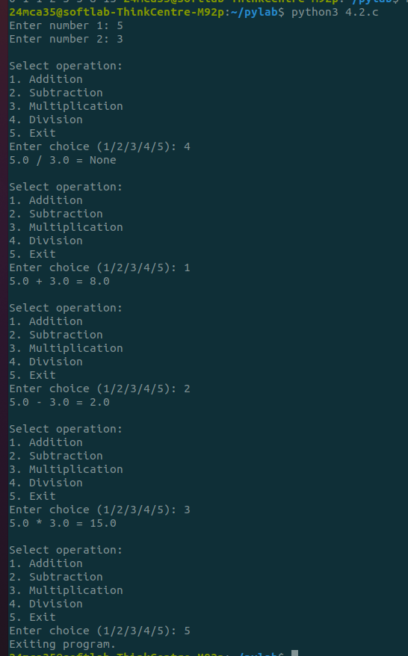
PGMM3

AIM:
Write a program to print the nth prime number. [Use function to check whether a number is prime or not]
SOURCE CODE:
def is_prime(num):
if num <= 1:
return False
for i in range(2, int(num ** 0.5) + 1):
if num % i == 0:
return False
return True

def nth_prime(n):
count = 0
num = 2
while count < n:
if is_prime(num):
count += 1
num += 1
return num - 1

n = int(input("Enter the value of n: "))
print(f"The {n}th prime number is: {nth_prime(n)}")

OUTPUT:
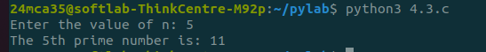

PGMM 4
AIM:
Write lambda functions to find the area of square, rectangle and triangle.

SOURCECODE:

GNU nano 4.8 4.4.c
area_of_square = lambda side: side * side

area_of_rectangle = lambda length, width: length * width

area_of_triangle = lambda base, height: 0.5 * base * height

side = 5
length = 10
width = 4
base = 6
height = 3

print(f"Area of square: {area_of_square(side)}")
print(f"Area of rectangle: {area_of_rectangle(length, width)}")
print(f"Area of triangle: {area_of_triangle(base, height)}")

OUTPUT:
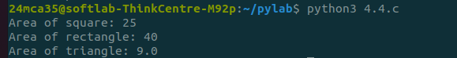

PGMM5
AIM:
Write a program to display powers of 2 using anonymous function. [ Hint use map and lambda function)

SOURCE CODE:

numbers = [0, 1, 2, 3, 4, 5, 6, 7, 8]

powers_of_2 = map(lambda x: 2 ** x, numbers)

print(list(powers_of_2))

OUTPUT:

PGMM6
AIM:
Write a program to display multiples of 3 using anonymous function. [ Hint use filter and lambda function)
SOURCE CODE:

numbers = list(range(1, 31))
multiples_of_3 = list(filter(lambda x: x % 3 == 0, numbers))
print("Multiples of 3:", multiples_of_3)

OUTPUT:

PGMM7
AIM:

Write a program to sum the series 1/1! + 4/2! + 27/3! + ….. + nth term. [ Hint Use a function to find the factorial of a number].

SOURCE CODE:

def factorial(num):
if num == 0 or num == 1:
return 1
else:
fact = 1
for i in range(2, num + 1):
fact *= i
return fact

def sum_series(n):
total_sum = 0
for i in range(1, n + 1):
term = (i ** i) / factorial(i) # (i^i) / i!
total_sum += term
return total_sum

n = int(input("Enter the value of n: "))
result = sum_series(n)
print(f"The sum of the series up to the {n}th term is: {result}")

OUTPUT:
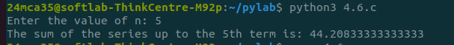

PGMM8
AIM:
Write a function called compare which takes two strings S1 and S2 and an integer n as arguments. The function should return True if the first n characters of both the strings are the same else the function should return False.

SOURCE CODE:

def compare(S1, S2, n):

if len(S1) < n or len(S2) < n:
return False

return S1[:n] == S2[:n]

S1 = input("Enter first string: ")
S2 = input("Enter second string: ")
n = int(input("Enter the value of n: "))

result = compare(S1, S2, n)
print(f"The result of comparison is: {result}")

OUTPUT:
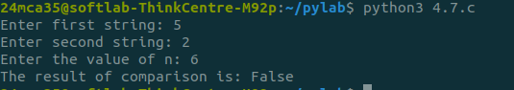

PGMM9
AIM:
Write a program to add variable length integer arguments passed to the function. [Also demo the use of docstrings]

SOURCE CODE:

def add_numbers(*args):
"""
Adds a variable number of integer arguments.
parameters:
*args:A variable length list of Integers to be added.
returns:
int:the sum of all the integers passed as argumens.
"""
if not all(isinstance(arg,int)for arg in args):
raise valueError("All arguments must be integers!!")
return sum(args)

print("sum of 1,2,3:",add_numbers(1,2,3))
print("sum of 10,20,30,40:",add_numbers(10,20,30,40))

OUTPUT:

PGMM10
AIM:
Write a program using functions to implement these formulae for permutations and combinations. The Number of permutations of n objects taken r at a time: p(n, r) = n!/(n − r)!. The Number of combinations of n objects taken r at a time is: c(n, r) = n!/(r! ∗ (n − r)!)

SOURCE CODE:

def factorial(num):
if num == 0 or num == 1:
return 1
else:
fact = 1
for i in range(2, num + 1):
fact *= i
return fact

def permutations(n, r):
return factorial(n) // factorial(n - r)

def combinations(n, r):
return factorial(n) // (factorial(r) * factorial(n - r))

n = int(input("Enter the value of n: "))
r = int(input("Enter the value of r: "))

p_result = permutations(n, r)
c_result = combinations(n, r)

print(f"The number of permutations p({n}, {r}) is: {p_result}")
print(f"The number of combinations c({n}, {r}) is: {c_result}")

OUTPUT:

